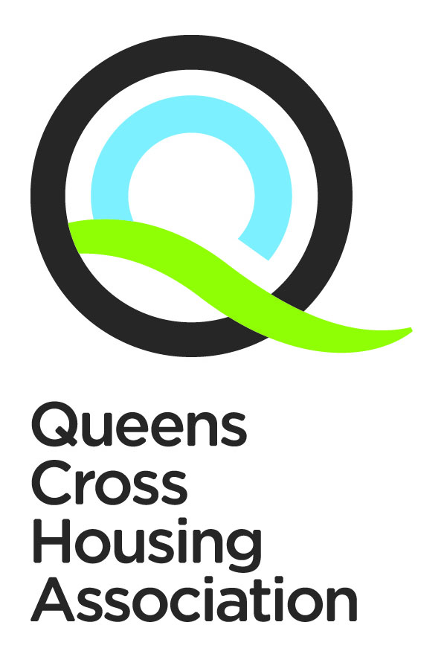
APPENDIX 2

Value for Money and Procurement Strategy
2024-2025

qcha.org.uk
0808 143 2002
contactus@qcha.org.uk

Our Vision, Values & Strategic Objectives
Our Vision, Values & Strategic Objectives

Our Vision

Excellent housing in vibrant communities

Our Values

Respect
We see the positive in everyone, especially our tenants. We treat everyone fairly, regardless of age, race, gender, sexuality or background. We ask for opinions even if we know we might not like what we hear. And we address people’s concerns in any way we realistically can.
Integrity
What we say in public is the same as what we say behind the scenes. If we say we’ll do something, we mean it. Our tenants can count on us to solve their problems and make sound decisions.
Aspiration
We want the best for all our current and future tenants. We’re not afraid to strive for things that won’t be easy – or try things that haven’t been done before. We seek out opportunities and welcome change. If it doesn’t turn out as planned, we learn and improve again. And then we try again.

Our Strategic Objectives

- Building and sustaining popular neighbourhoods
- Creating and supporting greater life opportunities for all
- Developing greener spaces and community wellbeing
- Being a dynamic and listening community partner
- Treating people equally and with respect

Contents

Section | Contents | Page
 | Foreword | 3
 | Introduction and background | 3
 | Where we are now | 4
 | Where we want to be…. Value for Money | 5
 | How we will get there….Value for Money | 7
 | Monitoring and Evaluation…..Value for Money | 9
 | Where we want to be…. Procurement | 10
 | How we will get there…Procurement | 12
 | Monitoring and Evaluation…. Procurement | 13
 | Footnotes and References | 14

1. Foreword
Queens Cross Housing Association’s business plan sets out our vision to provide excellent housing in vibrant communities. All our internal strategies exist to deliver on this vision and the strategic aims that support it.
This strategy on Value for Money and Procurement provides the Association with a framework to ensure that we deliver the best possible outcomes for tenants and other service users from every pound we spend both through external procurement and within the organisation. It supports the delivery of our overall corporate objectives within the regulatory and legislative environment that we operate in.

How effectively we procure goods, works and services has a fundamental impact on the success and service delivery of the organisation, and securing additional community benefits from our procurements is of particular value for a community based organisation like Queens Cross HA, working across communities which are affected by poverty and limited opportunities.

This strategy outlines how, through application and monitoring of our procurement practices, best value can be delivered and compliance with the Procurement Scotland Regulations can be assured. Against a background of high inflation across all service sectors, and ever increasing financial pressure on our customers, achieving best value from procurements and from our own services will be critical in the year ahead.

In this strategy we set out our strategic view and aims for procurement and value for money. It highlights the areas we will focus on over the next year and how we will measure progress and success.

John McIntyre
Board Member

2. Introduction and background
Queen’s Cross Housing Association’s commitment to Value for Money is driven by the desire to deliver the best possible outcomes for our customers from the resources and assets available to the association. To support our value for money vision, we strive to be an organisation with a full understanding of the cost, effectiveness, impact and demand for our services, informed by our knowledge of the community and customer needs.
Through our Value or Money approach, we are committed to achieving commercial excellence in our procurement activities, and to do so in an effective, efficient, ethical and sustainable way which delivers local economic, environmental and social benefits.
3. Where we are now
Queens Cross Housing Association was formed in 1976. We currently have over 4300 homes within our ownership, ranging from high rise multi storey blocks, to terraced and detached houses. We employ approximately 200 staff members and our turnover in 2021-2022 was over £25 million. We operate in the Dundasvale, Queens Cross, Woodside and Westercommon/Hamiltonhill areas of Glasgow. We are the lead company in a group structure, which includes Queens Cross Factoring Limited, a wholly owned subsidiary, delivering a factoring service to over 2,000 owners.
The Association’s stock and range of services has grown incrementally over the last 40 years but our focus on quality, efficiency, and therefore Value for Money (VfM), is longstanding, with an increasing focus on measuring and reporting VfM in recent years. The Association became a member of Housemark, the benchmarking organisation for social housing in 2012, and is continuing to develop the use of its techniques for benchmarking the cost, efficiency and effectiveness of our services, making comparisons over time and with a peer group of similar social landlords.
We include VfM measures within our performance reporting to tenants, and are engaged in a continual process of procurement reviews for all significant areas of expenditure. Within our financial planning, the Association has made a commitment to limiting rent increases to ensure rents remain affordable and has undertaken a rent restructure across the stock to ensure parity of rents for similar stock types.
In the last three years, our normal way of working and services to customers have been impacted by restrictions imposed by Scottish Government due to the Covid-19 pandemic. However, the Association maintained our VfM focus in each decision we took to adapt working practices and to support our customers, our staff and our business. Whilst additional expenditure was required in many areas, we worked to ensure that this was balanced with savings, and, in particular, we saw the benefits emerge from adopting agile working with reductions in facilities, training and travel costs.
Our most significant recurring expenditure on an annual basis is the contract for responsive maintenance works, including cyclical repairs and repairs to empty properties. The average spend per annum in this area has been over £3.5 million. The multi-year contract was re-procured in 2022 and awarded to a local SME and this contract started on the 1st of April 2023.
In addition, the Association has active programmes for the delivery of both the development of new build homes and capital investment works to existing homes. Some of these contracts are significant in value, duration, and impact on our customers and neighbourhoods, and our procurement processes are designed to comply with the requirements for public procurement, and to achieve excellent VfM for the Association.

Not all of our purchases of goods and services are high-value, and our procurement procedures encompass a range of potential routes including selective tendering, using existing external procurement frameworks, quick quote or desk based comparison etc. with the route selected depending on the value of works, goods or services being procured.

Planned procurements during 2021-22 was impacted by volatility in the marketplace causing reduced competition and price inflation as we saw the consequences of the Covid-19 pandemic, Brexit, and latterly, the war in Ukraine and the emerging cost of living crises. Both Development and Investment programmes have experienced delays resulting in procurements not proceeding in the year. In addition, some existing contracts have been altered, extended and/or re-procurement delayed in order to maintain our services at affordable (and predictable) costs.
4. Where we want to be……….Value for Money
4.1 Developing a VfM approach for Queens Cross

For the Association, Value for Money means delivering the best possible outcomes for our customers using the resources available to their maximum effect. The commonly used definition of VfM are the three components of economy, efficiency and effectiveness demonstrated within the following diagram :
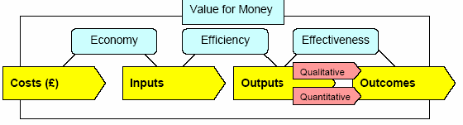

Economy is the price paid for what goes into providing a service, for example; the annual cost of a Housing Officer, the rent per square metre of office accommodation, the cost paid for specific repairs. Economy is also about minimising the cost of resources for an activity (doing things at a low price or achieving the best price or highest income for delivering a service) and therefore has a direct linkage to the procurement strategy outlined before.
Efficiency is a measure of productivity - how much you get out in relation to what is put in.
For example, the efficiency of services such as rent collection may be measured by the cost of the service compared to the rent roll. Similarly, tenant participation costs may be expressed as an annual sum amount per resident.
Efficiency is primarily associated with the process and delivery of procurement, i.e. performing tasks with reasonable effort ‘doing things the right way’.
Effectiveness is a measure of the impact achieved and can be quantitative or qualitative. For example Increasing the number of homes that Queens Cross has available to let, by reducing the time taken to renovate void property, in so doing reducing rent loss (quantitative); satisfaction levels among different sections of the community with community involvement arrangements (qualitative), and so on. Outcomes should be equitable across communities, so effectiveness measures will include aspects of equity. Effectiveness is associated with the outcomes for customers, i.e. the extent to which objectives are met (‘doing the right things’) and meeting the objectives of our business plan.
4.2 Overview of VfM strategic direction
Obtaining Value for Money is a priority for the Association. The ability to demonstrate to all our key stakeholders that best value is being achieved and provide the evidence is therefore important. We review on an on-going basis the performance and delivery of our service against our business plan objectives, as value for money is about effective delivery of our plans, as much as about cost.

Consequently the Queens Cross vision, values and business plan are all shaped by the drive to achieve VfM. The objectives flowing from the VfM Strategy are:
- Maximise the resources and income available to the association
- Working within agreed guidelines
- Deliver the best price/quality procurement of services and capital programmes
- Deliver a cost effective housing management service that gives high levels of resident satisfaction
- Maintain all homes economically and efficiently ensuring they provide a positive future cash-flow over the long term
- Deliver the best price/quality on management and maintenance
- Deliver the best price/quality for the procurement of goods and services
- Compare our price and quality with others.
Value for Money is not about achieving the cheapest price for our services, but about providing the highest quality service for our residents at the best price.

5. How we will get there….. Value for money
5.1 Queens Cross HA’s Best Value programme
A best value regime aims to ensure the delivery of quality services, not lowest price tendering. The Association will develop the capacity to make appropriate choices between different service delivery models and to be able to implement change across these successfully.

We will apply the “4 C's ethos” to each functions of our organisation i.e. to …..
• challenge why and how a service is being provided;
• compare with others’ performance;
• consult with service users and the key partners;
- employ competition to secure efficient and effective services in procurement.

5.2 The Best Value programme actions
The “4 C’s” ethos will be at the core of the Association’s business planning and annual budgeting process, evidenced by the following actions over the business planning period. These are presented using the 4 C’s model.
Challenge and comparison
- Continue to develop our understanding of where we are currently (through benchmarking e.g. Housemark, and through the development of our tenant satisfaction framework of surveys).
- VfM will be embedded across QCHA; all board reports include financial implications, full costings where appropriate and a clear statement of how the proposed expenditure supports organisational objectives.
- Continue to develop the use of service inspections and internal audit including working with the Residents Task Force.
- Either through Housemark or other collaborative agencies develop “critical friend” relationships to support service reviews.
- Ensure VfM is championed by the Board with the audit committee having responsibility for receiving reports and directing action.
- VfM audits will be undertaken as directed by the Executive, Board or audit committee.
- QCHA will develop its Service Plans and performance management tools and reports to allow more informed comparisons on performance against our own track record and/or our peers.
- Review Policies, procedures and organisational structures to ensure they support cost and performance management.
- The budgeting process will be reviewed to include greater elements of a zero based approach and embedded systematic reviews of expenditure and service delivery.
- Continue to maintain a system with clear budgetary lines of responsibility supported by strong financial reporting and management.
- Continue to develop Benchmarking of our performance on costs and service provision against other organisations as part of a benchmarking group such as Housemark and use this benchmark to inform our view of our costs and services.
- Encourage self-awareness of our performance and costs in a culture of ownership.
- Establish an annual target for efficiency gains against which recorded savings can be measured.
- Develop the reward scheme for staff or staff teams to encourage critical review of our processes.
- Support and participate in sector wide initiatives to develop better benchmarking and performance reporting i.e. Haymarket group.
- The Association will include more zero based elements within its budget planning.
- The management reporting structure will be reviewed to ensure that the appropriate managers are provided with necessary financial information to allow them to manage their operational activity. Reports are made to both Senior Management and the Board.
- The Director of Finance will be nominated as VfM lead to promote VfM work across QCHA, with the Board nominating a VfM champion.

Consultation
- VfM is a key element of a robust business planning process. We will develop our consultation process with key stakeholder groups such as the Residents Task Force to include greater VfM discussion.
- We will develop VfM partnerships with a useful neighbour or peer organisation.
- We will raise the profile of our VfM focus via staff training, and ensure VfM is a key agenda item at team meetings.
- We will strive to ensure the impact of any changes is equitable across our customers.
- We will consult with tenants on any proposed changes to ensure effectiveness is maintained.
- The Association will constantly look for ways to improve and encourage innovation.
- We will encourage a cross-departmental approach to Value for Money initiatives within Leadership Team discussions on a quarterly basis, to develop a potential VfM programme.
- The Leadership Team will work with their departmental teams to analyse service delivery models to seek improvements. Staff will be continually encouraged to come up with ideas that will enhance our service to our residents and can be rewarded via the Employee Suggestion Scheme.
- Promote the use of a VfM Register to measure success and allow reinvestment of efficiency gains and to communicate these gains to staff and other stakeholders.
Competition
- Our Procurement strategy will promote best value purchasing, creating competition on both quality and price criteria.
- The Association will ensure a systematic and regular approach to re-procurement of its services, challenging our suppliers to maintain competitive rates.
- We will ensure there is training and support to promote best practice in procurement processes and that relevant staff are aware of the organisational policies in place.

6. Monitoring and evaluation………Value For Money
The Association will record the processes we undertake towards achieving value for money and be able to demonstrate VfM through the actions as outlined above. This would include clear and transparent procurement processes, good financial reporting structures and budgetary ownership, savings registers, performance data and a structured programme and reports on value for money.
Whilst our VfM focus and activities will be on-going, we will report to the Board on our progress at appropriate points in our annual calendar (Business Planning, budget-setting etc.), and we will highlight VfM achievements to tenants in our annual performance review.
Under the terms of the Scottish Government’s guidance on its Affordable Housing Supply Programme; Process and Procedures, the Association must complete a value for money assessment of all completed development projects, based on cost, quality and time in a standard format from 9 to 15 months after completion, for national review.
7. Where we want to be……..Procurement
Over the next year, we continue to have ambitions to deliver our programme of planned investment in our assets across our area, and to build new assets via our development programme. As a result of inflation in the marketplace across all sectors, the Association has delayed procurement of contracts that had been planned to be placed in 2021/22 onwards. We are cautiously optimistic that the difficulties with material supplies and fuel costs will ease off in the year ahead, and the procurement environment will settle as suppliers regain their confidence, allowing our delayed procurements to proceed in the years ahead.
The scale of our activity is such that as a contracting authority, we must comply with the Procurement Reform (Scotland) Act 2014. We will procure these projects in line with the Public Contracts regulations, following closely the Scottish Government’s best practice procurement model as shown in the illustration on Page 11.
During the next three years, the Association will be procuring a number of Regulated Contracts (contracts for Goods and Services over £50,000 and Works over £2,000,000). The anticipated value for each of these and the year in which we plan to procure them, is shown in the Appendix 1.
For all regulated procurements, the Association follows the Scottish Model of Procurement, and will ensure that the most appropriate procurement route is selected to meet business needs and maximise VfM. For high-value or complex procurements, we may obtain external procurement expertise to guide us to a successful outcome which is fully compliant with legislation. For all regulated procurements, our strategy is to ensure:
- All relevant economic operators are treated equally and without discrimination;
- We act in a transparent and proportionate manner; and
- We comply with the “Sustainable Procurement duty”.
Our Procurement Procedures provide detailed guidance on the standard routes we will use for the majority of our procurements and explain the route selection process. The Association will maintain sufficient skills and resources within our Senior Management to design and deliver our procurements in-house, but may use external Frameworks where there is a clear VfM benefit in doing so, and these have been procured in a manner which aligns with our strategy i.e. using procurement processes that are sustainable and transparent, providing opportunities to local SMEs and Social Enterprises, providing excellent value for money, and will meet the objectives of our current Business Plan.
We aim to ensure that through procurement, we can deliver benefits to our local communities, and improve the local social, environmental, and economic opportunities, no matter which procurement route is selected. Our Community Benefits approach states minimum requirements for benefits to be delivered, which are proportionate to the contract value, but allows scope for variation and innovation to be negotiated with successful suppliers.
In line with the Association’s values, our aim is to place our contracts with suppliers who operate with integrity and social responsibility. Our pre-selection processes will be designed to consider potential suppliers in the round, including their track record of legal and financial diligence, employment practices, and commitment to meeting environmental and social responsibilities.

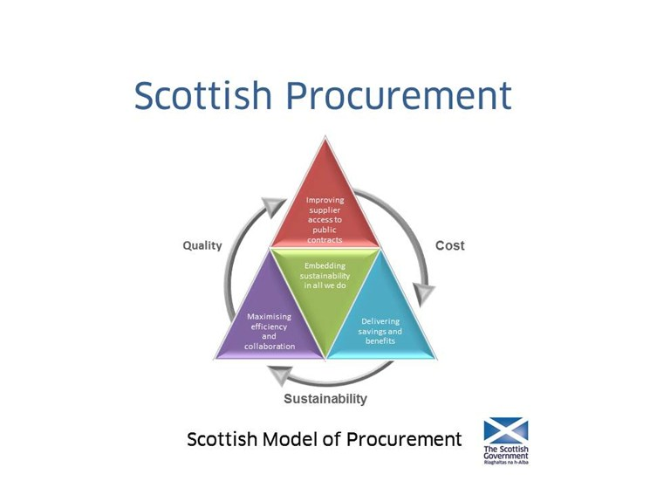

8. How we will get there….. Procurement
The following table outlines the Association’s approach to adhering to the Scottish Model of Procurement and delivering its strategic aims and objectives through our procurement strategy.

Strategic Aim | How we will Achieve This | Outcome
Delivering quality of service, savings and benefits | By planning our procurements carefully, selecting the best route to achieve the desired outcome  By balancing quality and price in the outcome, including consideration of whole life cost and added value offers  By understanding and reflecting our customers needs in service requirements  By applying our Community Benefits approach as a standard requirement in all procurements | Budget targets met  Value for money in short and long term - improved standards in service delivery and savings achieved  Suppliers deliver for customers (Customer First) and reflect the Association’s values  Community Benefits delivered in proportion to contract value
Maximising efficiency and collaboration | By monitoring procurement processes and outcomes, and identifying opportunities for innovation and areas for improvement  By drawing upon external Frameworks when there is a clear VfM benefit  By procuring goods and services as a Group (inc. the QC subsidiaries) or with other RSLs where our requirements align | Continuous improvement in procurement processes  Continue to meet legal and regulatory requirements with streamlined resources  Establish group approach and improve quality and efficiency
Improving supplier access to public contracts | By promoting opportunities across a range of media and using the Public Contracts Scotland portal for regulated procurements  By standardising and simplifying our procurement processes, including use of the ESPD for pre-qualification  By providing opportunities through the procurement process for SMEs and Social Enterprises  By collecting feedback from suppliers on our procurement processes | Increased awareness amongst suppliers and greater competition  SMEs and Social Enterprises have the opportunity to compete for contracts  Measurable benefits to the community  Continuous improvement in procurement processes
Embedding sustainability in all we do | By adopting a consistent (fair and transparent) procurement approach, and actively managing/monitoring supplier performance  By retaining “Living Wage” accreditation  By designing procurement routes to promote sustainability by i) using environmental metrics to compare potential suppliers and ii) engaging suppliers who can evidence ethical and sustainable practices e.g. positive Social / Environmental impacts, Equality and Diversity etc.  By publishing an annual report on procurement activities which reviews the outcomes against our targets | Positive long-term relationships with suppliers are developed  Our suppliers offer the real Living Wage to their employees  Wider economic, social and environmental benefits are achieved through procurement activity and evidence is gathered on a reduction in our Carbon Footprint  Sustainability goals remain central and targets are regularly refreshed

Scope
This strategy applies to all of the Association’s external expenditure on works, goods and services, and includes expenditure by subsidiary companies, e.g. Queens Cross Factoring and Queens Cross Workspace.

9. Monitoring and Evaluation………Procurement
Progress on outcomes set out in this strategy will be monitored on a regular basis by the following means;
- Planned procurements are detailed in the Association’s departmental plans which are monitored quarterly.
- A standard report is produced at the completion of all regulated contract procurements, confirming the business case, the selected procurement route and outcome, and will be reported to the Association’s Board or Executive, as appropriate to the value of the contract.
- An established Procurement Group, meeting throughout the year, with a remit to ensure implementation of the strategy and preparation of the Annual Report.
- A Contract Register is maintained centrally, recording key details of each contract procured, the value and duration, allowing for accurate reporting of procurement outcomes.
- Spend and performance against targets for placed contracts, are monitored by the relevant lead officer on a monthly basis, and performance variances are reported to the Executive officers.
- The Director of Finance and Corporate Support monitors overall spend against budget on a monthly basis.
- Under the terms of the Scottish Government’s guidance on its Affordable Housing Supply Programme; Process and Procedures, for the delivery of new housing developments, the Association must participate in a Procurement Improvement Programme every 2 years, which will assess all aspects of the Association’s Procurement performance (not just Development).
In compliance with the regulations, the Association will produce an annual report to the Board detailing;
- All contracts awarded in the year covered by the act.
- The process followed for each procurement in line with our procurement strategy and how we have complied with the legislation.
- Any community benefit requirements we have included in our contracts and any steps we have taken to involve ‘supported businesses’.
- Contracts covered by the Act expected in the next two years
In our annual report, we will review the success of completed procurements and evaluate our performance against the targets set in our Procurement strategy, and will make proposals to refresh our targets and the list of planned regulated procurements for the years ahead.
10. Footnotes and references

¹ | Procurement Scotland Regulations 2016
² | How do we know If we are providing value for money? Housemark Scotland
³ | Scottish Social Housing Charter 2012

Contact Us
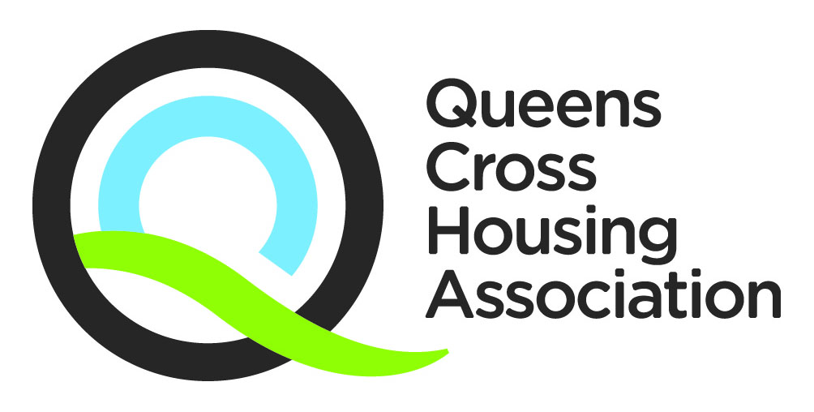

Telephone: 0808 143 2002
Email: contactus@qcha.org.uk
You can also download this document from our website at www.qcha.org.uk
Need another version of this document?

We can provide his document in different formats. If you would like a copy of this document in another language, in large print, in Easy Read, on audio tape, on video in British Sign Language (BSL), on CD or in Braille, please ask us.

